**Software Requirements Specification**

For

TradeHelp: A Helping Hand for Stock Market

3rd November 2023

Prepared by

| **Specialization** | **SAP ID** | **Name** |
| --- | --- | --- |
| AI&ML Hons B1 | 500090912 | Charu Gupta |
| AI&ML Hons B1 | 500094127 | Lakshay Agarwal |



Department of Artificial Intelligence

School Of Computer Science

UNIVERSITY OF PETROLEUM & ENERGY STUDIES,

DEHRADUN- 248007. Uttarakhand

**Table of Contents**

| **Topic** | | **Page No** |
| --- | --- | --- |
| Table of Content | |  |
|  | |  |
| 1 | Introduction |  |
|  | 1.1 Purpose of the Project |  |
|  | 1.2 Target Beneficiary |  |
|  | 1.3 Project Scope |  |
|  | 1.4 References |  |
| 2 | Project Description |  |
|  | 2.1 Reference Algorithm |  |
|  | 2.2 Data/ Data structure |  |
|  | 2.3 SWOT Analysis |  |
|  | 2.4 Project Features |  |
|  | 2.5 User Classes and Characteristics |  |
|  | 2.6 Design and Implementation Constraints |  |
|  | 2.7 Design diagrams |  |
|  | 2.8 Assumption and Dependencies |  |
| 3 | System Requirements |  |
|  | 3.1 User Interface |  |
|  | 3.2 Software Interface |  |
|  | 3.3 Database Interface |  |
|  | 3.4 Protocols |  |
| 4 | Non-functional Requirements |  |
|  | 4.1 Performance requirements |  |
|  | 4.2 Security requirements |  |
|  | 4.3 Software Quality Attributes |  |
| 5 | Other Requirements |  |
| Appendix A: Glossary | |  |
| Appendix B: Analysis Model | |  |
| Appendix C: Issues List | |  |

1. INTRODUCTION:

Purpose of The Project

Nowadays, investing our money into the stock market is a booming trend. Over time, people have understood the worth of making their money earn for them rather than just keeping it in the bank with hardly any returns. The stock market is one of the most chosen options. Other choices can range from anything like property, gold, mutual funds, etc.

The stock market has the highest potential for extremely high returns. But this comes along with the highest risk factor too. Another big problem is managing so much of past data and analyzing it to crack the trend of stock prices. This data analysis can be done by ML with much greater accuracy than that of humans.

TradeHelp project is inspired by the growing need for reliable stock market predictions and well-informed decision-making, which aims to have important consequences for monetary gain and risk management. In this project, we will combine technical expertise with a strong interest in finance and offer helpful instructional resources for anyone looking to grasp data analysis and machine learning in a real-world setting.

Target Beneficiary

Developing an accurate stock market prediction system is essential due to the volatility and unpredictability of financial markets. Current methods often fall short, creating risks and missed opportunities for investors.

This project aims to create a reliable predictive model to improve decision-making, manage risks, and gain a competitive edge in the financial industry while considering ethical and regulatory implications.

Project Scope

Stock market predictions can be used for a variety of purposes and can benefit various types of users, including:

* **Investment decision-making:** Investors can use stock market predictions to make informed decisions about which stocks to buy, sell, or hold.
* **Risk management**: Stock market predictions can be used to help investors manage their risk by identifying stocks that are likely to be more volatile.
* **Trading strategies**: Stock market predictions can be used to develop trading strategies that exploit market inefficiencies.
* **Economic forecasting:** Stock market predictions can be used to help economists forecast economic growth and inflation.

References

[1] Karim, Rezaul & Alam, Md & Hossain, Rezaul. (2021). Stock Market Analysis Using Linear Regression and Decision Tree Regression.

[2] Seethalakshmi, Ramaswamy. (2018). Analysis of stock market predictor variables using linear regression. International Journal of Pure and Applied Mathematics.

[3] Amit Gupta, T.J.Nagalakshmi. (2019). Stock Price Prediction using Linear Regression in Machine Learning.

[4]https://medium.com/@isirabandarafb/stock-market-prediction-using-linearregression-modeling-5a1c9b510254

1. PROJECT DESCRIPTION:

Dataset

The dataset used is in csv format.

It has two rows and 2793 columns.

The dataset is freely available for research purposes, and it has been used in a wide range of applications.

SWOT Analysis

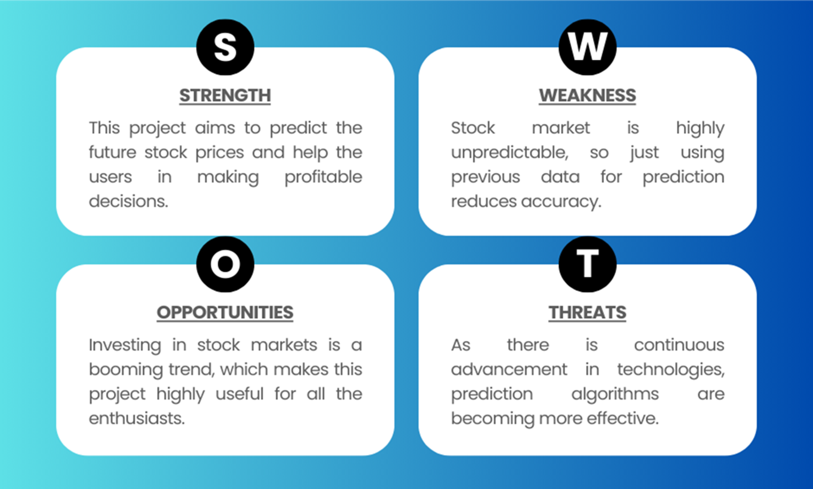

Project Features

The methodology for our TradeHelp using deep learning techniques can be outlined as follows:

**Dataset Collection**: Firstly, a large dataset of stock prices is collected for training the machine learning model.

**Model Selection**: The next step is to select the machine learning models that will be used for prediction. Several popular prediction models are Regression, Random Forest, etc.

**Model Training**: The ML model learns predictions from the training data and predicts future stock prices.

**Model Evaluation**: After training, the model needs to be evaluated on a separate validation dataset to assess its performance.

**Model Optimization**: Based on the evaluation results, the model can be finetuned and optimized to improve its performance.

User Classes and Characteristics

It can be used for the following user classes:

* Investment Bankers
* Economist
* Traders
* Researchers and Academics

Design and Implementation Constraints

* Parameter: TradeHelp could actually use an enormous number of factors to evaluate the future stock prices. But to actually build a model we have to limit our considered parameters.
* Language Limitation: Constrained to use only C++ in the project had a huge effect on limiting the model’s potential.
* Dataset: If we took all the parameters into consideration, then the dataset would have to be really huge so that model doesn’t overfit to the dataset.

Design Diagram

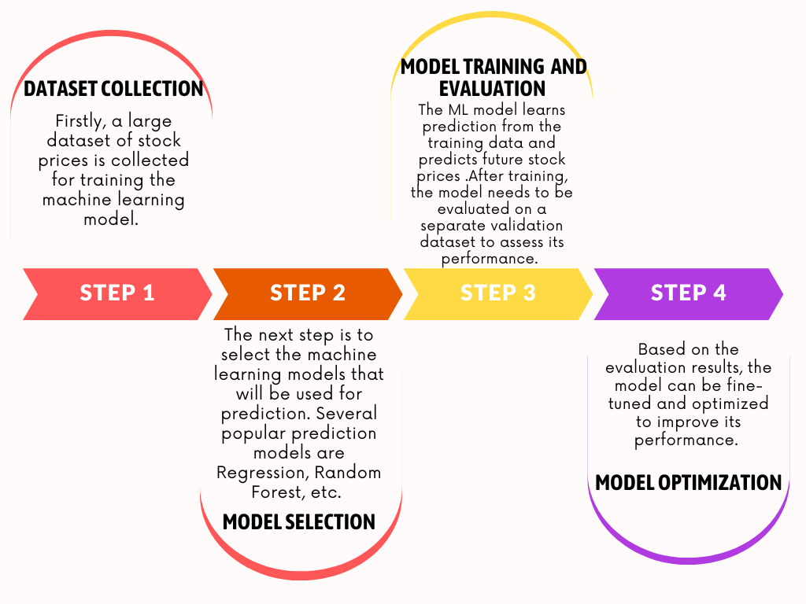

Fig 1. Workflow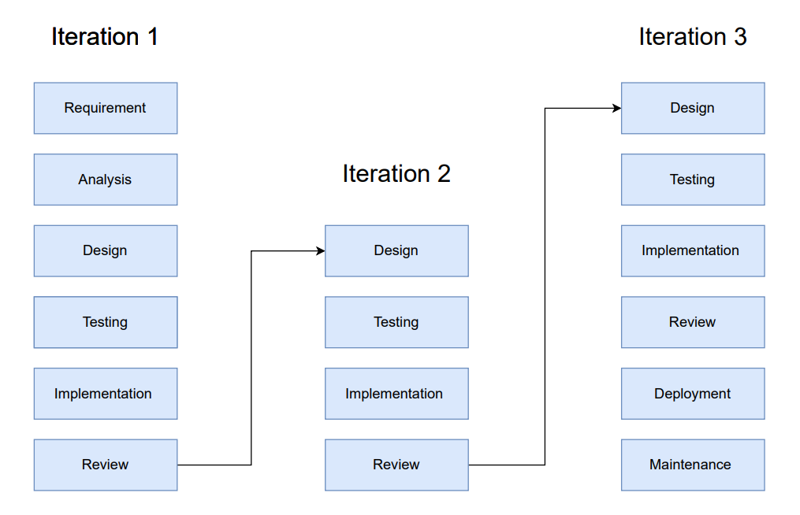

Fig 2. Iterative Model

Assumption and Dependencies

Our Project has certain assumptions as mentioned below:

* That the data is linearly dependent.
* That prediction of future stock prices can be done only using past prices.

1. SYSTEM REQUIREMENTS:

User Interface

We have used the command line interface to generate the output window for displaying our predictions.

Software Interface

Not applicable

Database Interface

Not applicable

Protocols

Not applicable

1. NON-FUNCTIONAL REQUIREMENTS:

Performance Requirements

The basic requirement to run this project is to have a proper installation of C++ with various extensions and the availability of GPU in the local system. It enables high-speed parallel processing of large amounts of data, allowing to build simple linear regression models.

Security Requirements

The dataset is readily available on the internet. The files of our project have been uploaded on GitHub so it is accessible to everyone.

Software Quality Attributes

Availability ensures a system remains operational and accessible, critical for business systems and online services, directly impacting user satisfaction and business continuity. Reliability guarantees consistent, error-free performance, crucial in safety-critical applications, where any failure can lead to severe consequences. Usability focuses on user-friendliness, enhancing user satisfaction, productivity, and adoption, which is especially vital in consumer-facing applications with an intuitive and efficient user experience.

APPENDIX A: GLOSSARY

* Linear Regression- It is used to predict the value of a variable based on the value of another variable. The variable you want to predict is called the dependent variable. The variable you are using to predict the other variable's value is called the independent variable.
* Linearly dependent- a set of vectors is linearly dependent if one of the vectors can be written as a sum of scalar multiples of the other vectors.
* Parameters- are the unknown coefficients that determine the relationship between the independent variable(s) and the dependent variable. These parameters are estimated from a set of data using a statistical method, such as the method of least squares. The estimated parameters are then used to predict the dependent variable for new data points.